**Project 12: Working with DynamoDB**

Task 1: Create a DynamoDB Table with minimum two disaster recovery zones and verify replication

* disaster recovery regions with the tables that are present in two different regions.

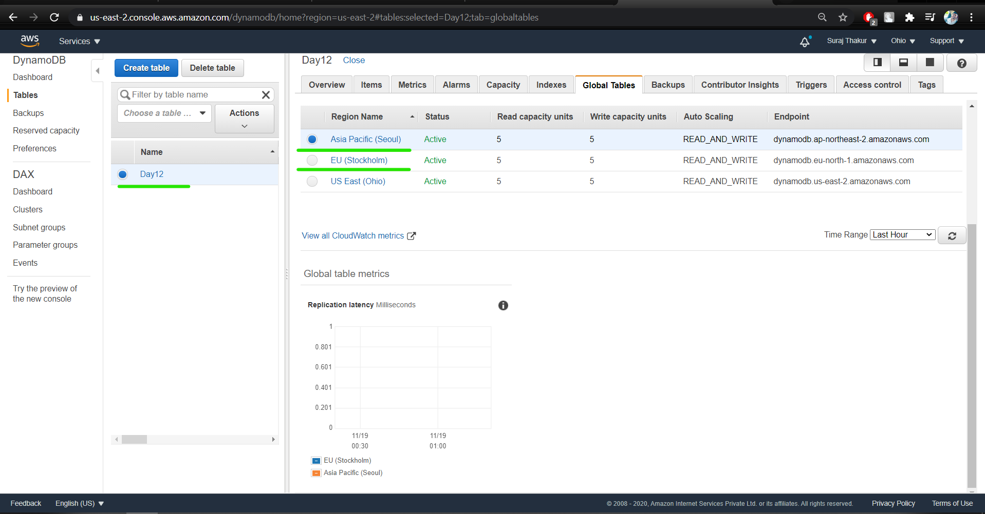

* Home regions with all items displayed

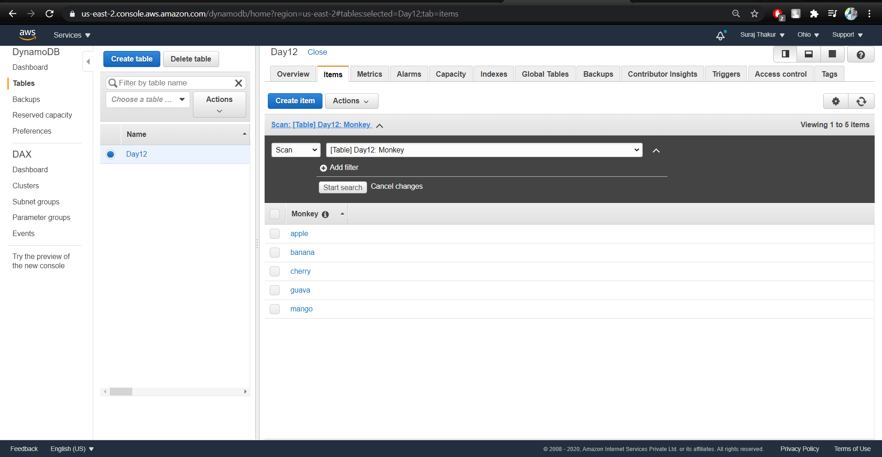

* Within the list of items, use query to fetch the item

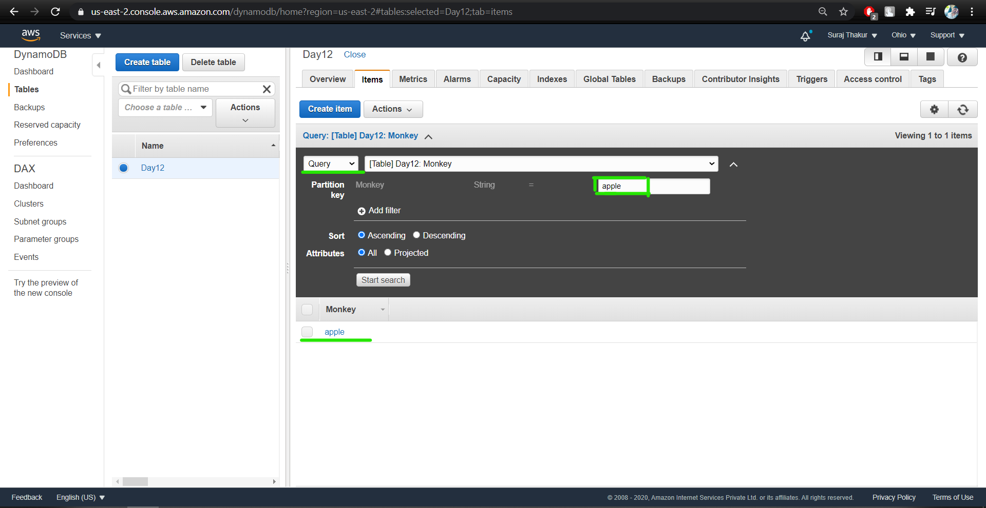

* After fetching the data, now delete the table

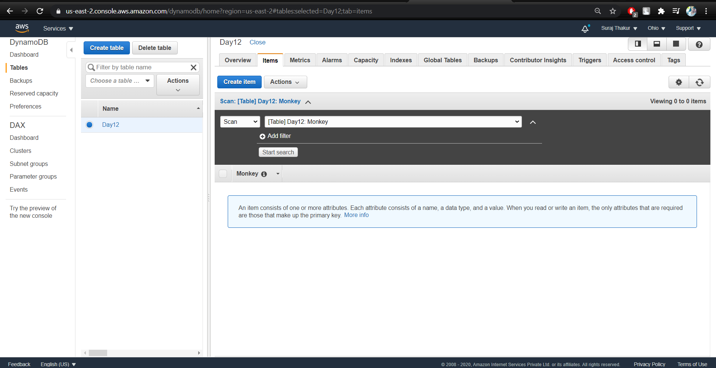

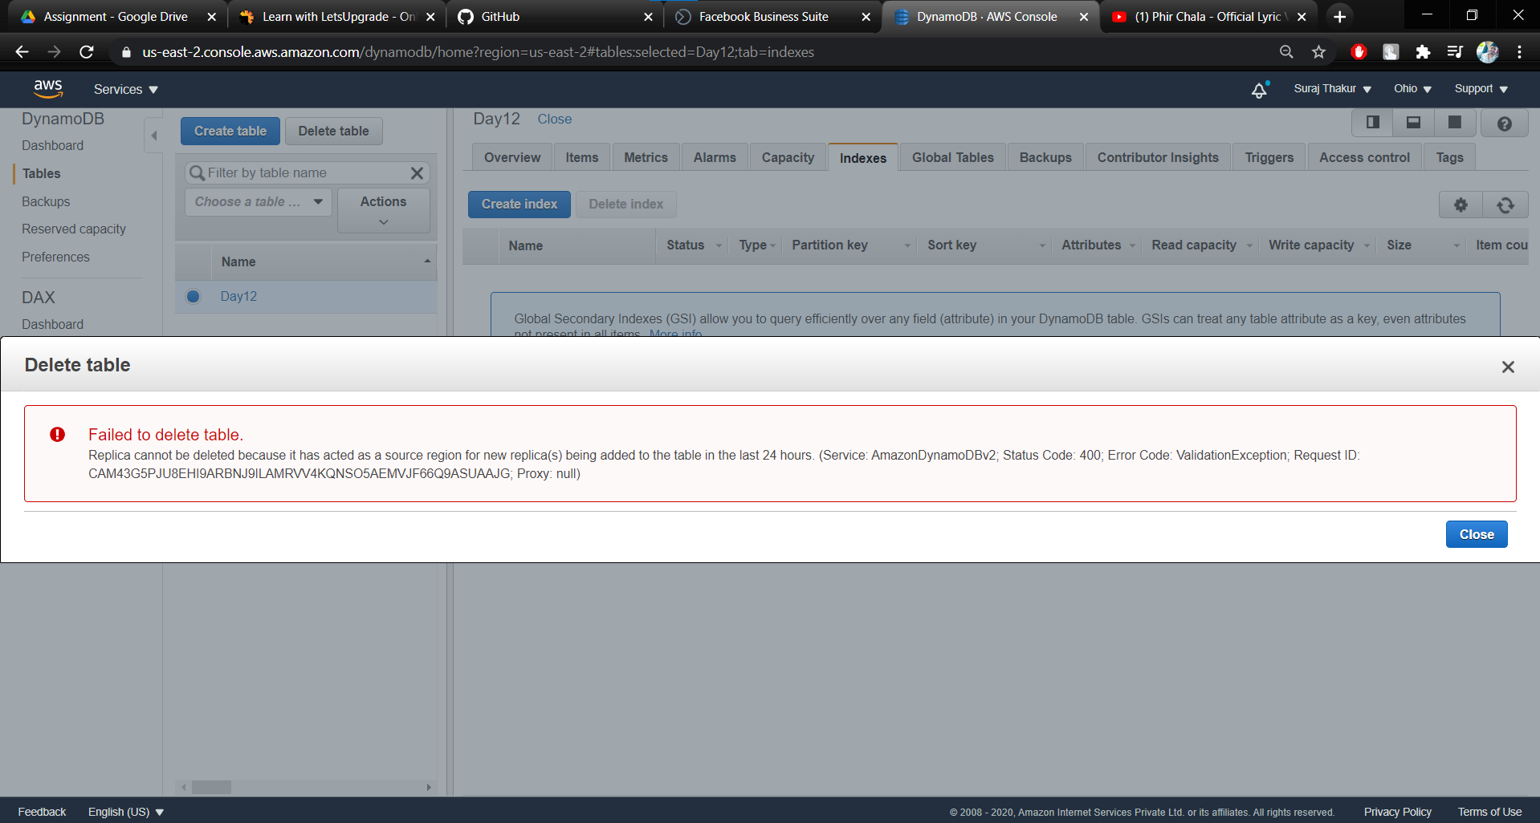

Task 2: Create a DynamoDB table with indexes

